Case study business problem

**Statement:** “Company ABC wants to build html generator where users can select the components in the html screen by dragging and dropping cards, buttons and other available html components to design html look and feel. The user should be able to resize the components and position them as per their requirement. Once done, they can save the html which will generate the html in the desired layout.”

**Proposed approach for implementation of the above-mentioned feature:**

* To build a HTML generator tool for users, the company ABC can use **GrapesJS** and can use **GrapesJS API** for editor to extend the basic functionality of the framework and could also create a plugin and make those extensions reusable and available to others.

**What is GrapesJS?**

GrapesJS is a multi-purpose, Web Builder Framework, which means it allows us to easily create a drag & drop enabled builder of "things". By "things" I mean anything with HTML-like structure, which entails much more than web pages. It use HTML-like structure basically everywhere: Newsletters, Native Mobile Applications, Native Desktop Applications, PDFs, etc. So, for everything we can imagine as a set of elements like <tag some="attribute">... other nested elements ...</tag>we can create easily a GrapesJS builder around it and then use it independently in our applications. GrapesJS ships with features and tools that enable us to craft easy to use builders.

***Which will allow Company ABC’s users to create complex HTML-like templates without any knowledge of coding.***

In a nutshell, GrapesJS is a Free and Open Source Web Builder Framework and a next generation tool for building templates without coding..

**Why GrapesJS?**

GrapesJS was designed primarily for use inside Content Management Systems to speed up the creation of dynamic templates and replace common WYSIWYG editors. Which are good for content editing, but inappropriate for creating HTML structures. Instead of creating an application GrapesJS developers decided to create an extensible framework that could be used by anyone for any purpose. According to me it’s the best suited framework that can be used to create HTML generator by Company ABC and the company can also add plugins to extend the features of GrapesJS and to make their HTML generator more Powerful and easy to use for their clients/users.

**The code is there when you need it:** We don't have to care about the code, but it's always there, available for us. When the work is done, we can grab and use it wherever we want. Developers could also implement their own storage interfaces to use inside the editor.

**Demo Template (Screenshot)**

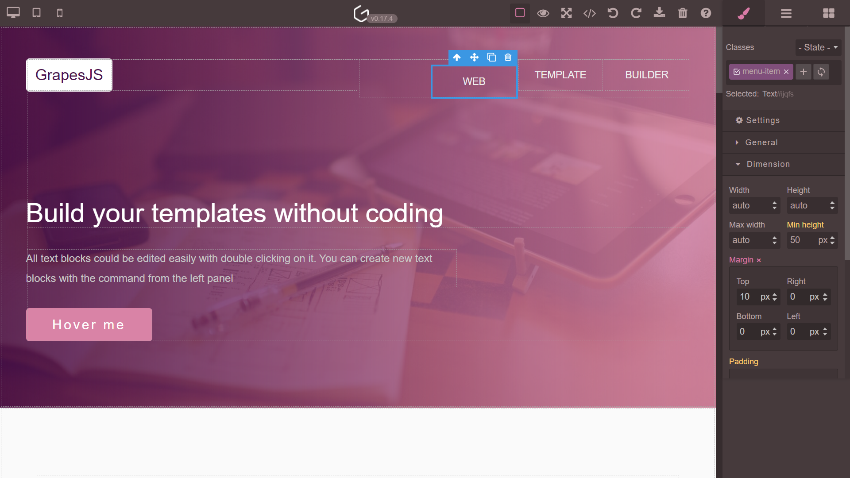

**Automatically Genereated Code**

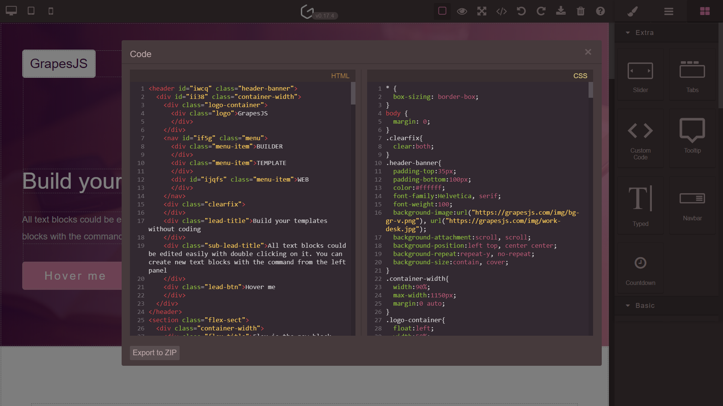

**Publicly available resources (Papers/Articles) that I referred to for implementation of the solution:**

* [**https://grapesjs.com/**](https://grapesjs.com/)
* [**https://github.com/artf/grapesjs**](https://github.com/artf/grapesjs)
* [**https://grapesjs.com/docs/api/editor.html#editor**](https://grapesjs.com/docs/api/editor.html#editor)
* [**https://www.w3schools.com/html/html5_draganddrop.asp**](https://www.w3schools.com/html/html5_draganddrop.asp)
* [**https://www.digitalocean.com/community/tutorials/js-drag-and-drop-vanilla-js**](https://www.digitalocean.com/community/tutorials/js-drag-and-drop-vanilla-js)